Isaiah 52:13-53:12 Behold the Servant
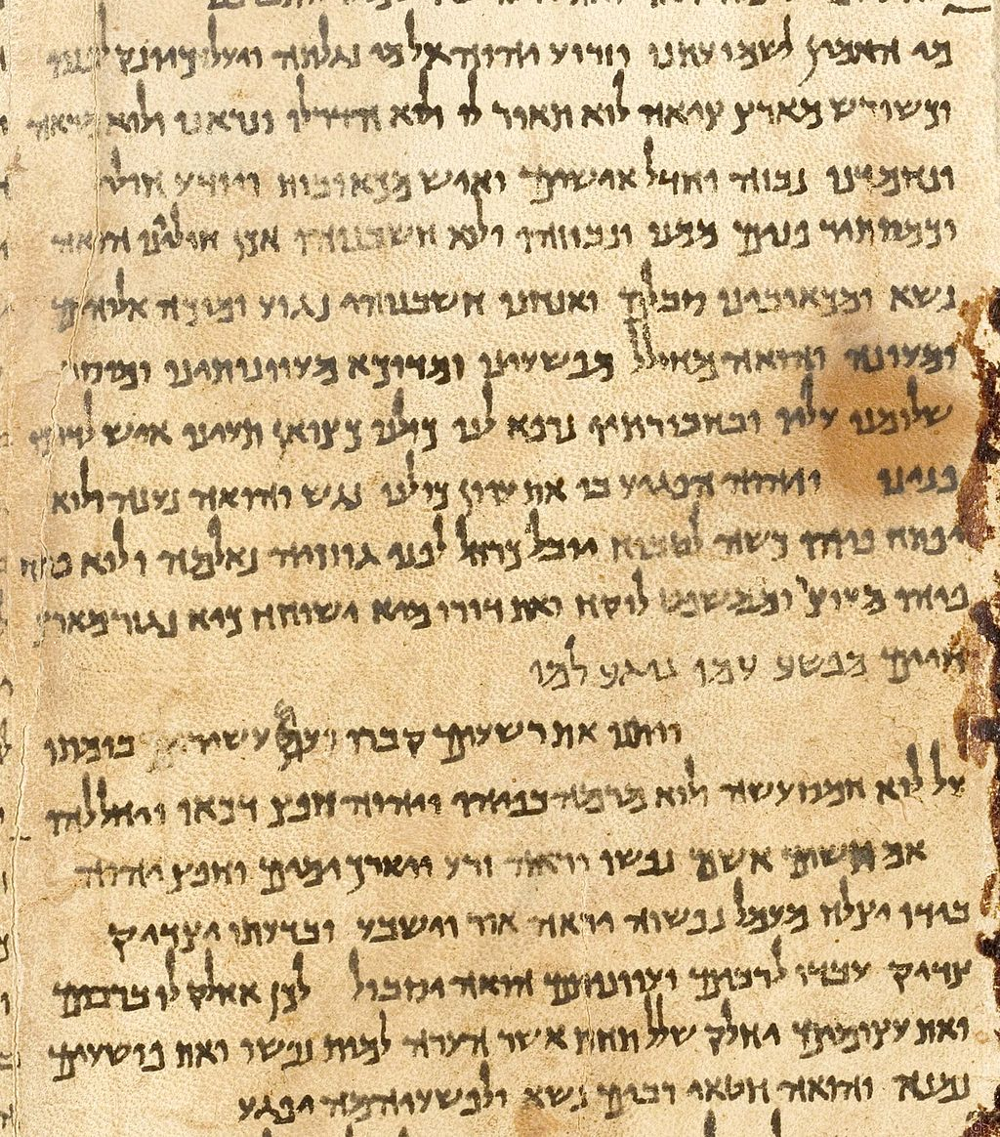
Extreme importance

Behold!

• Wise (52:13-15)

• Despised (53:1-3)

• Substitute (53:4-6)

• Innocent (53:7-9)

• Victorious (53:10-12)

The Servant in Isaiah

• Forgiveness for Isaiah (6:7)

• Forgiveness for Israel (40:2; 52:7)

The Servant in the New Testament

• Connections (eg. Luke 22:37; Acts 8:32-35)

• Significance (eg. Mark 10:45; John 1:29; 1 Cor 15:1-4)

The Servant in 2016

• Written for us (1 Peter 1:10-12)

• Beautiful feet (Romans 10:9-17)

• Follow in his footsteps (1 Peter 2:21-25)

UPCOMING EVENTS:

New Comers Lunch 21st-Feb
If you are new or visiting Stromlo and would like to hear more about Stromlo Christian Church please join us for lunch at 12.30 at The Stromlo Hub in the Weston Community Centre at Cooleman Court.

Life Groups
Life Groups are starting to meet around Canberra. If you are looking for a group to attend please contact Dave McDonald to find out what groups are in your area. dave@stromlo.org

The Lord’s Supper will be shared together today.

Ultimate Youth meet on Friday nights 7.30pm-9.15pm at the Hub in Cooleman Court. It is for young people in grades 7-12. Come and join us. Contact Andrew Buesnel youth@stromlo.org 0417 027 346
ROSTER:
http://stromlo.org/roster/
Password: Stromlo
REGULAR EVENTS: (during school terms)
Life Groups Contact Ken Mansell treasurer@stromlo.org 0429 566 516
Women’s Life Groups Contact Sarah Wheeley sarahwheeley@gmail.com 0421 345 153
Ultimate youth Friday nights 7:30-9:15pm, Stromlo Hub. Contact Andrew Buesnel youth@stromlo.org 0417 027 346

Behold the Servant

Isaiah 52-53

Dave McDonald

- I would like to find out more about following Jesus
- I am new to Stromlo Christian Church
- Please add me to the directory
- I heard about Stromlo Christian Church from:
- I would like to get involved with a midweek Life Group
- Please add me to the Stromlo Christian Church email list
- I would like to talk to someone about serving

Please write comments, questions or prayer requests on the back

21st February 2016
Next Sunday:
We are looking at Isaiah 55 Isaiah with Dave McDonald.

Visiting?
If you are visiting this morning, thanks for joining us. Please stick around for a cuppa and a chat!

Communication
For more news and events sign up to Stromlo Christian Church’s email list by filling out a feedback card and placing in the clear box on the information table. Communications from our Lead Pastor can be found at http://stromlo.org/news/
If you would like to listen to this week’s Bible talk, or missed a previous one, you can download them online at stromlo.org

21st February 2016
Name:.…………………………………………………... m/f
Spouse: ………………….... Children (+ ages): ……..…...
…………………………………………………………………
Address:………………………………………………………..………………………………………… Postcode:….……..
Ph.(h) ………………………… (m) .………………………..
Email:………………………………………………………….

To support Stromlo Christian Church financially grab an Investing in Eternity brochure from the information desk, or download one from: http://stromlo.org/investing-eternity/
Bank Details: Bank: Commonwealth, Account Name: Stromlo Christian Church Inc.
BSB: 062 912 Account Number: 10227783

Lead Pastor: Dave McDonald dave@stromlo.org 0419 557 775
Assistant Pastor: Dan Evers dan@stromlo.org 0424 665 183
Office: Julianne McMaster office@stromlo.org 0412 720 069
Stromlo Kids: Sarah Rootes kids@stromlo.org 0432 642 442
Ultimate (Youth): Andrew Buesnel youth@stromlo.org
Communications: Hope Watson news@stromlo.org
Stromlo Council: Phil Ng secretary@stromlo.org
Treasurer: Ken Mansell treasurer@stromlo.org

