Isaiah 65:17 – 66:24 Our heart’s desire

Our heart’s desire (Isaiah 65)

• Lasting happiness (17-19)

• Eternal life (20)

• Lasting lifestyle (21-22)

• Divine blessing (23-24)

• Beyond Eden (25)

Living in the presence of greatness (Isaiah 66)

• God cannot be boxed (1-2)

• Worship God wants (2)

• Worship God despises (3)

• Mission-hearted worship (18-21)

• An awful end (22-24)

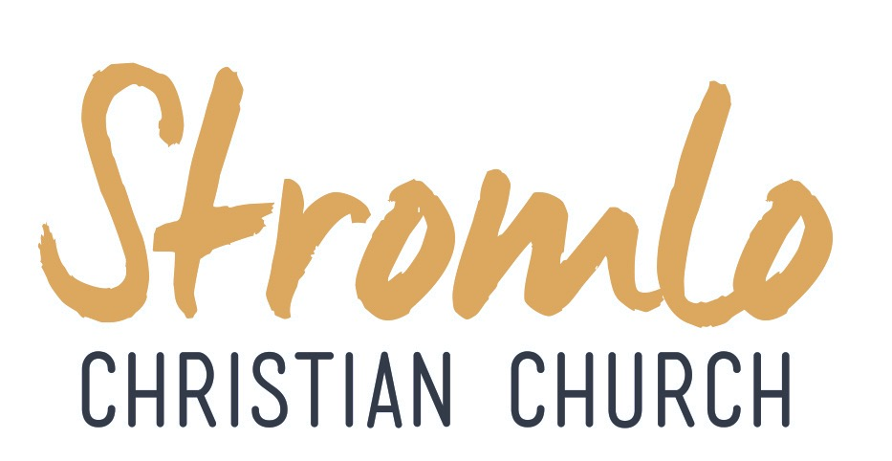

The Joy of the Resurrection

Matthew 28

Dan Evers
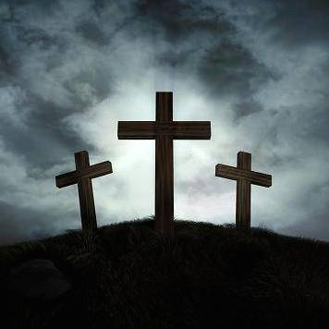

Next Sunday:
We are looking at 2 Timothy 1: 1-14 Time for Action with Dave McDonald.

Life Groups
Are you interested in joining one of our weekly small group Bible studies?
Contact Dan Evers dan@stromlo.org

UPCOMING EVENTS:
3rd April MAD Lunch with Navigators
come and hear about the work of the Navigators in the Australian Defence Force.
Introducing God starting soon:
If you would like to know more talk to Dan Evers or email dan@stromlo.org

We are excited to be moving location to Coombs Primary.
Here is the timetable for our transition:
Sun 3/4 | Walk through school facilities
Mon 4/4 | Prayer Meeting @ Hub 7-8pm
Sun 10/4 | Last Sunday @ Stromlo High
Sat 16/4 | Setup and Prayer @ Coombs
Sun 17/4 | First Sunday @ Coombs
Sun 24/4 | Last Sunday of School holidays
Sun 1/5 | First Sunday of Term 2
Mon 2/5 | Prayer Meeting @ Hub 7-8pm
Sun 8/5 | Second Sunday of Term 2
Sun 15/5 | Public Launch @ Coombs

Lead Pastor: Dave McDonald dave@stromlo.org 0419 557 775
Associate Pastor: Dan Evers dan@stromlo.org 0424 655 183
Office: Julianne McMaster office@stromlo.org 0412 720 069
Stromlo Kids: Sarah Rootes kids@stromlo.org 0432 642 442
Ultimate (Youth): Andrew Buesnel youth@stromlo.org
Communications: Hope Watson news@stromlo.org
Stromlo Council: Phil Ng secretary@stromlo.org
Treasurer: Ken Mansell treasurer@stromlo.org

- I would like to find out more about following Jesus
- I am new to Stromlo Christian Church
- Please add me to the directory
- I heard about Stromlo Christian Church from:
- I would like to get involved with a midweek Life Group
- Please add me to the Stromlo Christian Church email list
- I would like to talk to someone about serving

Please write comments, questions or prayer requests on the back

27th March 2016

Name:.…………………………………………………... m/f
Spouse: ………………….... Children (+ ages): ……..…...
…………………………………………………………………
Address:………………………………………………………..………………………………………… Postcode:….……..
Ph.(h) ………………………… (m) .………………………..
Email:………………………………………………………….

To support Stromlo Christian Church financially grab an Investing in Eternity brochure from the information desk, or download one from: http://stromlo.org/investing-eternity/
Bank Details: Bank: Commonwealth, Account Name: Stromlo Christian Church Inc.
BSB: 062 912 Account Number: 10227783

27th March 2016

