Matthew 9:35–10:15
35 Jesus went through all the towns and villages, teaching in their synagogues, proclaiming the good news of the kingdom and healing every disease and sickness. 36 When he saw the crowds, he had compassion on them, because they were harassed and helpless, like sheep without a shepherd. 37 Then he said to his disciples, “The harvest is plentiful but the workers are few. 38 Ask the Lord of the harvest, therefore, to send out workers into his harvest field.”
10 Jesus called his twelve disciples to him and gave them authority to drive out impure spirits and to heal every disease and sickness.
2 These are the names of the twelve apostles: first, Simon (who is called Peter) and his brother Andrew; James son of Zebedee, and his brother John; 3 Philip and Bartholomew; Thomas and Matthew the tax collector; James son of Alphaeus, and Thaddaeus; 4 Simon the Zealot and Judas Iscariot, who betrayed him.
5 These twelve Jesus sent out with the following instructions: “Do not go among the Gentiles or enter any town of the Samaritans. 6 Go rather to the lost sheep of Israel. 7 As you go, proclaim this message: ‘The kingdom of heaven has come near.’ 8 Heal the sick, raise the dead, cleanse those who have leprosy, drive out demons. Freely you have received; freely give.
9 “Do not get any gold or silver or copper to take with you in your belts— 10 no bag for the journey or extra shirt or sandals or a staff, for the worker is worth his keep. 11 Whatever town or village you enter, search there for some worthy person and stay at their house until you leave. 12 As you enter the home, give it your greeting. 13 If the home is deserving, let your peace rest on it; if it is not, let your peace return to you. 14 If anyone will not welcome you or listen to your words, leave that home or town and shake the dust off your feet. 15 Truly I tell you, it will be more bearable for Sodom and Gomorrah on the day of judgment than for that town.
Finding compassion
Not my problem

The King’s mission strategy

• Compassion calls for prayer (9:35-38; Ezekiel 34)

• Jesus’ strike force! (10:1-4)

• The details matter (5-10; 10:18; 28:18-20; Romans 1:16)

• It’s what you do with it (11-15)

Finding compassion

• Talk with God

• To reach out to others

UPCOMING EVENTS:
NEXT SUNDAY 9.30am
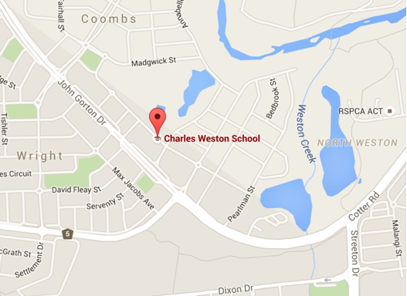
Charles Weston Primary School
80 Woodberry Avenue, Coombs ACT 2611

Introducing God starting soon:
If you would like to know more talk to Dan Evers or email dan@stromlo.org

Finding Compassion

Matthew 9-10

Dave McDonald

Next Sunday:
We are looking at Matthews 10 with Dave McDonald.

Life Groups
Are you interested in joining one of our weekly small group Bible studies?
Contact Dan Evers dan@stromlo.org

We are excited to be moving location to Coombs Primary.
Here is the timetable for our transition:

Sun 10/4 | Last Sunday @ Stromlo High
Sat 16/4 | Setup and Prayer @ Coombs
Sun 17/4 | First Sunday @ Coombs
Sun 24/4 | Last Sunday of School holidays
Sun 1/5 | First Sunday of Term 2 and MAD Lunch
Mon 2/5 | Prayer Meeting @ Hub 7-8pm
Sun 8/5 | Second Sunday of Term 2
Sun 15/5 | Public Launch @ Coombs

Lead Pastor: Dave McDonald dave@stromlo.org 0419 557 775
Associate Pastor: Dan Evers dan@stromlo.org 0424 655 183
Office: Julianne McMaster office@stromlo.org 0412 720 069
Stromlo Kids: Sarah Rootes kids@stromlo.org 0432 642 442
Ultimate (Youth): Andrew Buesnel youth@stromlo.org
Communications: Hope Watson news@stromlo.org
Stromlo Council: Phil Ng secretary@stromlo.org
Treasurer: Ken Mansell treasurer@stromlo.org

- I would like to find out more about following Jesus
- I am new to Stromlo Christian Church
- Please add me to the directory
- I heard about Stromlo Christian Church from:
- I would like to get involved with a midweek Life Group
- Please add me to the Stromlo Christian Church email list
- I would like to talk to someone about serving

Please write comments, questions or prayer requests on the back

10th April 2016

Name:.…………………………………………………... m/f
Spouse: ………………….... Children (+ ages): ……..…...
…………………………………………………………………
Address:………………………………………………………..………………………………………… Postcode:….……..
Ph.(h) ………………………… (m) .………………………..
Email:………………………………………………………….

To support Stromlo Christian Church financially grab an Investing in Eternity brochure from the information desk, or download one from: http://stromlo.org/investing-eternity/
Bank Details: Bank: Commonwealth, Account Name: Stromlo Christian Church Inc.
BSB: 062 912 Account Number: 10227783

Next Sunday
we meet at
Charles Weston Primary at 9.30am

10th April 2016

