Hebrews 10:19-25

19 Therefore, brothers and sisters, since we have confidence to enter the Most Holy Place by the blood of Jesus, 20 by a new and living way opened for us through the curtain, that is, his body, 21 and since we have a great priest over the house of God, 22 let us draw near to God with a sincere heart and with the full assurance that faith brings, having our hearts sprinkled to cleanse us from a guilty conscience and having our bodies washed with pure water. 23 Let us hold unswervingly to the hope we profess, for he who promised is faithful. 24 And let us consider how we may spur one another on toward love and good deeds, 25 not giving up meeting together, as some are in the habit of doing, but encouraging one another—and all the more as you see the Day approaching.

Hebrews 4:14-16

14 Therefore, since we have a great high priest who has ascended into heaven, Jesus the Son of God, let us hold firmly to the faith we profess. 15 For we do not have a high priest who is unable to empathize with our weaknesses, but we have one who has been tempted in every way, just as we are—yet he did not sin. 16 Let us then approach God’s throne of grace with confidence, so that we may receive mercy and find grace to help us in our time of need.

Time to reconnect

Feeling disconnected?

Connect with God

• Look back

• Look ahead

Connect with one another

• Look around

UPCOMING EVENTS:

29th May: AGM following Church

28th May Equip Live Stream
3-9pm @ Stromlo Hub $20 includes dinner.

Ultimate Parents: Expressions of interest for ‘the Parenting Teenagers Course’ from 27th May-24th June at 7.30-9.00pm while Ultimate is on. Contact Dan@stromlo.org for further info.

5th June Community Soup Lunch.

- I would like to find out more about following Jesus
- I am interested in attending an Introducing God Dinner
- Please add me to the directory/ email list (circle)
- I heard about Stromlo Christian Church from:
- I would like to get involved with a midweek Life Group
- I am new to Stromlo Christian Church.
- I would like to talk to someone about serving

Please write comments, questions or prayer requests on the back

Next Sunday:
We will be looking at 1 Corinthinas 3.

Life Groups
Are you interested in joining one of our weekly small groups?
Contact Dan Evers dan@stromlo.org

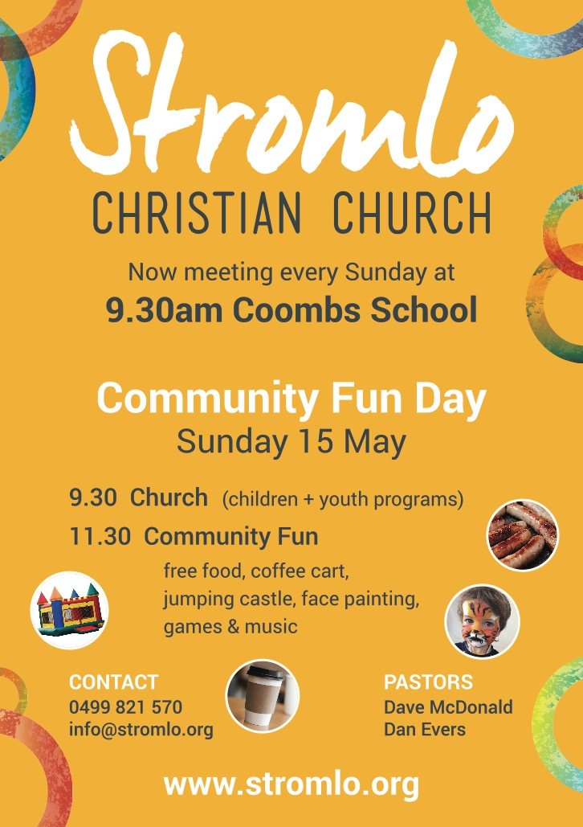

Lead Pastor: Dave McDonald dave@stromlo.org 0419 557 775
Associate Pastor: Dan Evers dan@stromlo.org 0424 655 183
Office: Julianne McMaster office@stromlo.org 0499 821 570
Stromlo Kids: Sarah Rootes kids@stromlo.org 0432 642 442
Ultimate (Youth): Andrew Buesnel youth@stromlo.org
Communications: Hope Watson news@stromlo.org
Stromlo Council: Phil Ng secretary@stromlo.org
Treasurer: Ken Mansell treasurer@stromlo.org

Name:.…………………………………………………... m/f
Spouse: ………………….... Children (+ ages): ……..…...
…………………………………………………………………
Address:………………………………………………………..………………………………………… Postcode:….……..
Ph.(h) ………………………… (m) .………………………..
Email:………………………………………………………….

To support Stromlo Christian Church financially grab an Investing in Eternity brochure from the information desk, or download one from: http://stromlo.org/investing-eternity/
Bank Details: Bank: Commonwealth, Account Name: Stromlo Christian Church Inc.
BSB: 062 912 Account Number: 10227783

15th May 2016

Praying for Jonno: Please be praying for Jonno, Lucy, Phoebe and the extended family as they grieve the loss of Becky. If you need to talk with someone do not hesitate to contact Dave McDonald.

