1 Corinthians 3

1 Brothers and sisters, I could not address you as people who live by the Spirit but as people who are still worldly—mere infants in Christ. 2 I gave you milk, not solid food, for you were not yet ready for it. Indeed, you are still not ready. 3 You are still worldly. For since there is jealousy and quarreling among you, are you not worldly? Are you not acting like mere humans? 4 For when one says, “I follow Paul,” and another, “I follow Apollos,” are you not mere human beings?
5 What, after all, is Apollos? And what is Paul? Only servants, through whom you came to believe—as the Lord has assigned to each his task. 6 I planted the seed, Apollos watered it, but God has been making it grow. 7 So neither the one who plants nor the one who waters is anything, but only God, who makes things grow. 8 The one who plants and the one who waters have one purpose, and they will each be rewarded according to their own labor. 9 For we are co-workers in God’s service; you are God’s field, God’s building.
10 By the grace God has given me, I laid a foundation as a wise builder, and someone else is building on it. But each one should build with care. 11 For no one can lay any foundation other than the one already laid, which is Jesus Christ. 12 If anyone builds on this foundation using gold, silver, costly stones, wood, hay or straw, 13 their work will be shown for what it is, because the Day will bring it to light. It will be revealed with fire, and the fire will test the quality of each person’s work. 14 If what has been built survives, the builder will receive a reward. 15 If it is burned up, the builder will suffer loss but yet will be saved—even though only as one escaping through the flames.
16 Don’t you know that you yourselves are God’s temple and that God’s Spirit dwells in your midst? 17 If anyone destroys God’s temple, God will destroy that person; for God’s temple is sacred, and you together are that temple.
18 Do not deceive yourselves. If any of you think you are wise by the standards of this age, you should become “fools” so that you may become wise. 19 For the wisdom of this world is foolishness in God’s sight. As it is written: “He catches the wise in their craftiness”; 20 and again, “The Lord knows that the thoughts of the wise are futile.” 21 So then, no more boasting about human leaders! All things are yours, 22 whether Paul or Apollos or Cephas or the world or life or death or the present or the future—all are yours, 23 and you are of Christ, and Christ is of God.

Don’t waste your time in the church

Don’t waste your time…

NB. The sustained argument (1:10-4:21)

Telling it like it is (1-4)

Attitude to Christian leaders (5-9a)

Attitude to church and ministry (9b-17)

Final encouragement (18-23)

UPCOMING EVENTS:

29th May: AGM following Church
Beginning after the service. Financial documents are on the back table if you would like to look at it.

28th May Equip Live Stream
3-9pm @ Stromlo Hub $20 includes dinner.
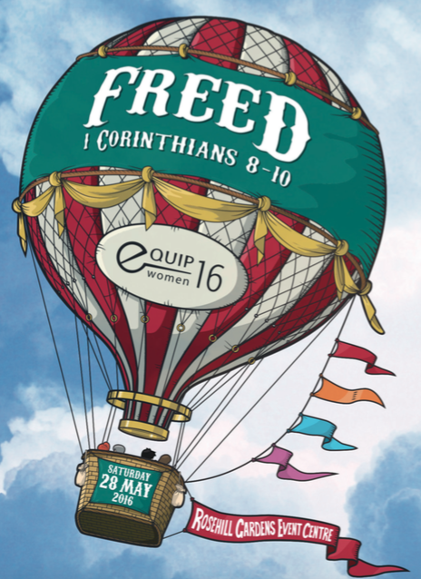

Ultimate Parents: Expressions of interest for ‘the Parenting Teenagers Course’ from 27th May-24th June at 7.30-9.00pm while Ultimate is on. Contact dan@stromlo.org for further info.

5th June Community Soup Lunch.
If you would like to make a Soup let Louise Marks know phone 0400 315 978.

- I would like to find out more about following Jesus
- I am interested in attending an Introducing God Dinner
- Please add me to the directory/ email list (circle)
- I heard about Stromlo Christian Church from:
- I would like to get involved with a midweek Life Group
- I am new to Stromlo Christian Church.
- I would like to talk to someone about serving

Please write comments, questions or prayer requests on the back

Next Sunday:
We will be looking at 1 Corinthinas 4.

Life Groups
Are you interested in joining one of our weekly small groups?
Contact Dan Evers dan@stromlo.org

1 Corinthians 3
Don’t Waste Your Time in the Chruch

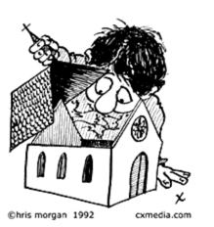

Name:.…………………………………………………... m/f
Spouse: ………………….... Children (+ ages): ……..…...
…………………………………………………………………
Address:………………………………………………………..………………………………………… Postcode:….……..
Ph.(h) ………………………… (m) .………………………..
Email:………………………………………………………….

Lead Pastor: Dave McDonald dave@stromlo.org 0419 557 775
Associate Pastor: Dan Evers dan@stromlo.org 0424 655 183
Office: Julianne McMaster office@stromlo.org 0499 821 570
Stromlo Kids: Sarah Rootes kids@stromlo.org 0432 642 442
Ultimate (Youth): Andrew Buesnel youth@stromlo.org
Communications: Hope Watson news@stromlo.org
Stromlo Council: Phil Ng secretary@stromlo.org
Treasurer: Ken Mansell treasurer@stromlo.org

To support Stromlo Christian Church financially grab an Investing in Eternity brochure from the information desk, or download one from: http://stromlo.org/investing-eternity/
Bank Details: Bank: Commonwealth, Account Name: Stromlo Christian Church Inc.
BSB: 062 912 Account Number: 10227783

22nd May 2016

22nd May 2016

Praying for Jonno: Please be praying for Jonno, Lucy, Phoebe and the extended family as they grieve the loss of Becky. If you need to talk with someone do not hesitate to contact Dave McDonald.

