1 Corinthians 2:6-16

1 And so it was with me, brothers and sisters. When I came to you, I did not come with eloquence or human wisdom as I proclaimed to you the testimony about God. 2 For I resolved to know nothing while I was with you except Jesus Christ and him crucified. 3 I came to you in weakness with great fear and trembling. 4 My message and my preaching were not with wise and persuasive words, but with a demonstration of the Spirit’s power, 5 so that your faith might not rest on human wisdom, but on God’s power.
6 We do, however, speak a message of wisdom among the mature, but not the wisdom of this age or of the rulers of this age, who are coming to nothing. 7 No, we declare God’s wisdom, a mystery that has been hidden and that God destined for our glory before time began. 8 None of the rulers of this age understood it, for if they had, they would not have crucified the Lord of glory. 9 However, as it is written:
“What no eye has seen, what no ear has heard,
and what no human mind has conceived”—
the things God has prepared for those who love him—
10 these are the things God has revealed to us by his Spirit. The Spirit searches all things, even the deep things of God. 11 For who knows a person’s thoughts except their own spirit within them? In the same way no one knows the thoughts of God except the Spirit of God. 12 What we have received is not the spirit of the world, but the Spirit who is from God, so that we may understand what God has freely given us. 13 This is what we speak, not in words taught us by human wisdom but in words taught by the Spirit, explaining spiritual realities with Spirit-taught words. 14 The person without the Spirit does not accept the things that come from the Spirit of God but considers them foolishness, and cannot understand them because they are discerned only through the Spirit. 15 The person with the Spirit makes judgments about all things, but such a person is not subject to merely human judgments, 16 for,
“Who has known the mind of the Lord so as to instruct him?”
But we have the mind of Christ.
True spirituality

Those who get it, those who don’t (1-9)

• Foolishness

• Not that kind of wisdom

• But this kind of wisdom

• Failure to understand

Why some get it, why some don’t (10-16)

• The Spirit gives understanding

• Only the Spirit can give understanding

• Spiritual discernment

What it means to be Spiritual

• Anchored to the cross of Christ

• Humility before God

• Humility before others

UPCOMING EVENTS:

15th May Stromlo Community Fun Day

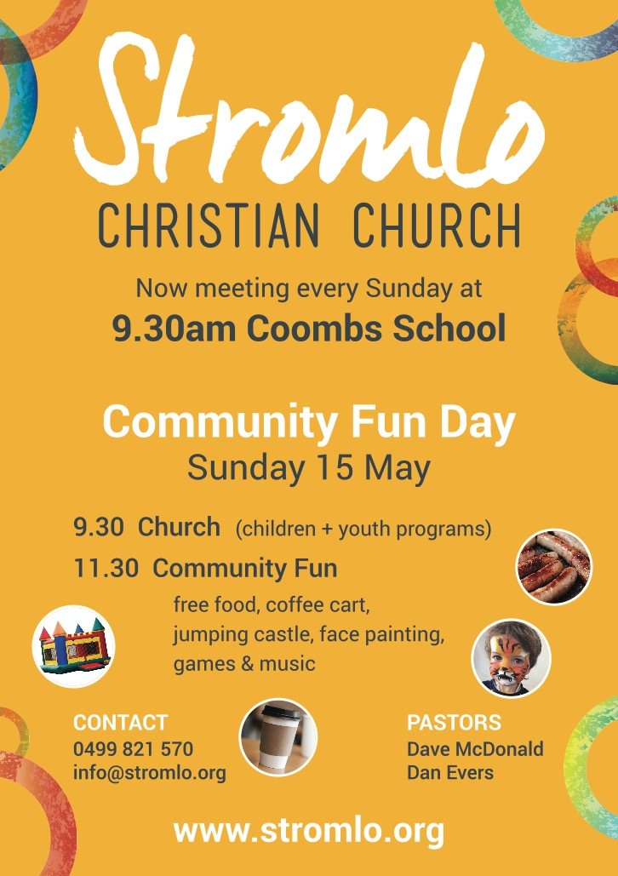
28th May Equip Live Stream
3-9pm @ Stromlo Hub $20 includes dinner.

Next Sunday:
Community Fun Day with Dave McDonald
Life Groups
Are you interested in joining one of our weekly small groups?
Contact Dan Evers dan@stromlo.org

True Spirituality
1 Corinthians 2: 6-16

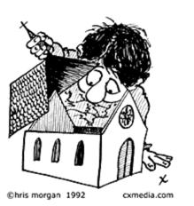

8th May 2016

Lead Pastor: Dave McDonald dave@stromlo.org 0419 557 775
Associate Pastor: Dan Evers dan@stromlo.org 0424 655 183
Office: Julianne McMaster office@stromlo.org 0412 720 069
Stromlo Kids: Sarah Rootes kids@stromlo.org 0432 642 442
Ultimate (Youth): Andrew Buesnel youth@stromlo.org
Communications: Hope Watson news@stromlo.org
Stromlo Council: Phil Ng secretary@stromlo.org
Treasurer: Ken Mansell treasurer@stromlo.org

- I would like to find out more about following Jesus
- I am new to Stromlo Christian Church
- Please add me to the directory
- I heard about Stromlo Christian Church from:
- I would like to get involved with a midweek Life Group
- Please add me to the Stromlo Christian Church email list
- I would like to talk to someone about serving

Please write comments, questions or prayer requests on the back

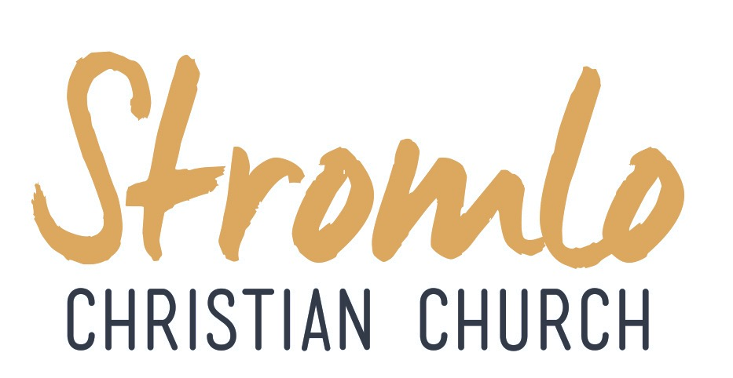
Name:.…………………………………………………... m/f
Spouse: ………………….... Children (+ ages): ……..…...
…………………………………………………………………
Address:………………………………………………………..………………………………………… Postcode:….……..
Ph.(h) ………………………… (m) .………………………..
Email:………………………………………………………….

To support Stromlo Christian Church financially grab an Investing in Eternity brochure from the information desk, or download one from: http://stromlo.org/investing-eternity/
Bank Details: Bank: Commonwealth, Account Name: Stromlo Christian Church Inc.
BSB: 062 912 Account Number: 10227783

Praying for Jonno: Please be praying for Jonno, Lucy, Phoebe and the extended family as they grieve the loss of Becky. If you need to talk with someone do not hesitate to contact Dave McDonald.

8th May 2016

