The fear factor

Proverbs 1:7 (NIV)

The fear of the LORD is the beginning of knowledge,
but fools despise wisdom and instruction.

How to read Proverbs

1. Come to the king for wisdom (1:1)

2. Fear the LORD
(1:7; 9:10; De 10:12; Ps 111:10; Job 28:28; Ec 12:13)

Who is the LORD?

• Powerful Creator (Gen 1)

• Holy Judge (Gen 3, 6-9; Heb 11:7; Ex 20:18-20; Is 6:5; 8:11-13)

• And the New Testament (Ac 5:11; Lu 12:4-5; He 12:28-29)

• The Lord Jesus Christ (2 Th 1:8-9; Rev 6:15-17)

• But what about…? (1 John 4:18)

Wisdom for life

• What about…? (1 John 4:18)

• Comparing 1 Peter (1:17; 2:18; 3:2,14,15)

• Laying the foundation

• Building on it (Acts 9:31; Phil 2:12; 1 Pet 1:17-19)

The Fear Factor
Proverbs 1:7

31st July 2016
UPCOMING EVENTS

6 August 2016
At men’s convention this year
Phil Campbell will be speaking
from Judges.
Register today at
www.canberrachristiancovention.org.au

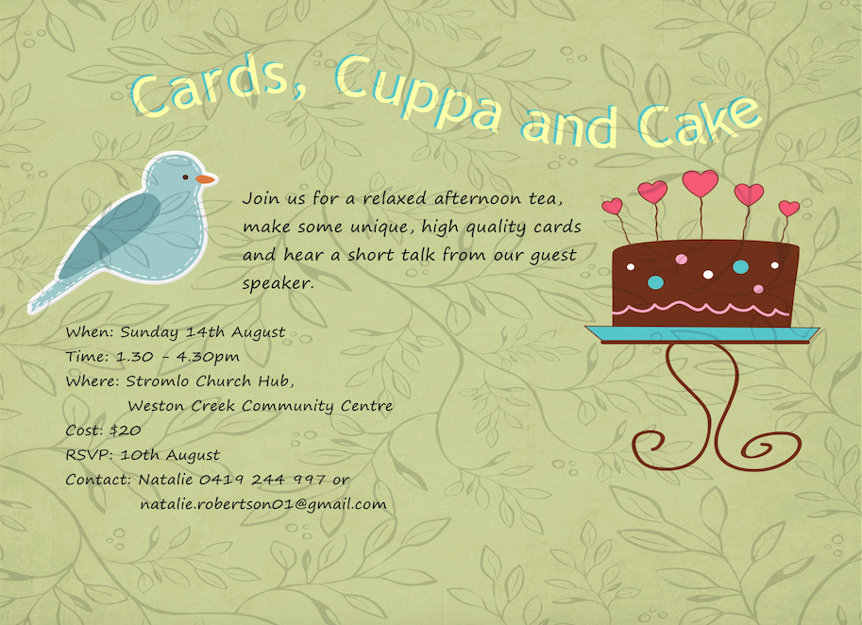
Women's Event: card making on Sunday 14th Aug, 1.30 to 4.30pm, $20 at the Hub. Invite a friend! Speaker: Skye Evers

Save the date:
Ultimate Youth Camp
9-11th September
Years 6-12
Next Sunday:
We will be looking at “Sons and Lovers”
Proverbs 1-9 with
Dave McDonald

Next Sunday 7th August Community Lunch. Curry Lunch, contact Regan & Linden Vine to help
reganjvine@gmail.com
0410538231 (Linden)

- I would like to find out more about following Jesus
- Please add me to the directory/ email list (circle)
- I heard about Stromlo Christian Church from:
- I would like to get involved with a midweek Life Group
- I am new to Stromlo Christian Church.
- I would like to talk to someone about serving

Please write comments, questions or prayer requests on the back
31st July 2016
Name:.…………………………………………………... m/f
Spouse: ………………….... Children (+ ages): ……..…...
…………………………………………………………………
Address:………………………………………………………..………………………………………… Postcode:….……..
Ph.(h) ………………………… (m) .………………………..
Email:………………………………………………………….

To support Stromlo Christian Church financially grab an Investing in Eternity brochure from the information desk, or download one from: http://stromlo.org/investing-eternity/
Bank Details: Bank: Commonwealth, Account Name: Stromlo Christian Church Inc.
BSB: 062 912 Account Number: 10227783

Lead Pastor: Dave McDonald dave@stromlo.org 0419557775
Associate Pastor: Dan Evers dan@stromlo.org 0424 655 183
Office: office@stromlo.org 0499 821 570
Stromlo Kids: Sarah Rootes kids@stromlo.org 0432 642 442
Ultimate (Youth):
Andrew Buesnel
youth@stromlo.org
Communications: news@stromlo.org
Stromlo Council: Phil Ng secretary@stromlo.org
Treasurer: Michael Spark treasurer@stromlo.org

